1.Check availability of books

create procedure chk_avail2(in bname varchar(20), out msg varchar(20), out bcount int)

begin

select no_of_copies into bcount from book_master where name = bname;

if bcount = 0 then

set msg = 'Book not available';

end if;

end;

$

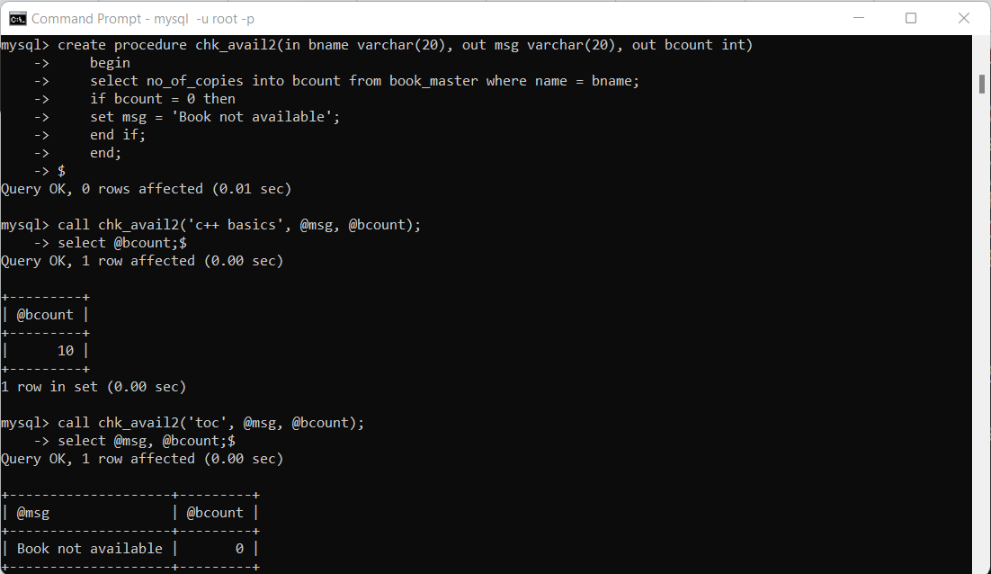

2. Fine

create function calc_fine_amount(b_id int, s1_id int)

returns int

DETERMINISTIC

begin

declare f_amt int;

declare days int;

declare i_date, r_date date;

select issue_date, returned_date into i_date, r_date from transaction where

book_id=b_id and s_id=s1_id;

select(r_date-i_date) into days from transaction where book_id=b_id and s_id=s1_id;

if days>15 then

set f_amt:=(days-15)*10;

else

set f_amt:=0;

end if;

return f_amt;

end;

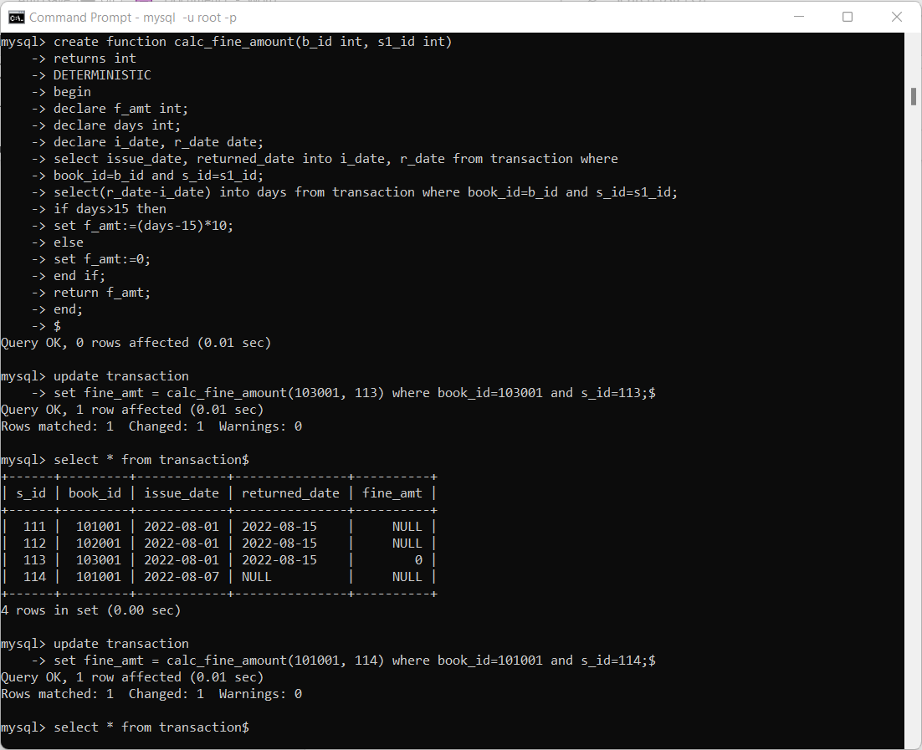

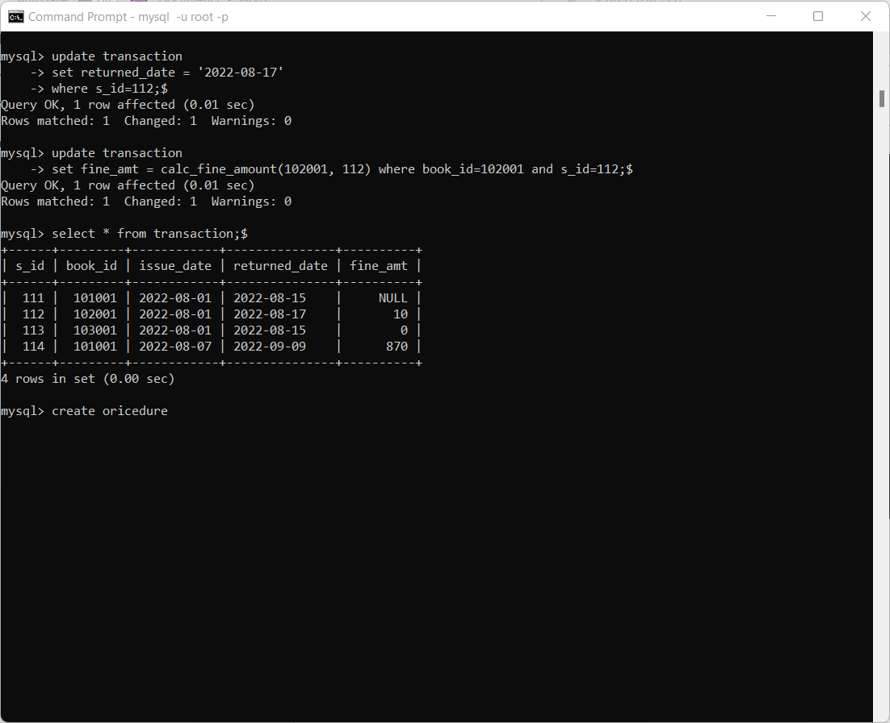

3. students not accessed library

Create procedure nul_student_list1(out n varchar(400))

Begin

Declare name_n varchar(20);

Declare done int default 0;

Declare c2 cursor for select name from student where s_id not in (select s_id from transaction);

Declare continue handler for not found set done=1;

Set n=” ”;

Open c2;

Myloop:loop

Fetch c2 into name_n;

Select name_n;

If done=1 then

Leave myloop;

End if;

Set n=concat(n,” ”,name_n);

Select n;

End loop myloop;

Close c2;

End;

